Virtual R Data Analyst Internship
Final Report
Comprehensive Data Analysis of the Titanic Passenger Data
Data Cleaning, Visualization, Statistical Testing and Predictive Modeling in R
Tool: R (RGui) with dplyr, ggplot2, corrplot, pROC and car
Name: Abinisha P

Contents
Executive Summary
1. Introduction
2. Data and Methodology Overview
3. Data Preparation (Week 1)
4. Exploratory Analysis and Visualization (Weeks 1 and 2)
5. Statistical Testing (Week 3)
6. Predictive Modeling (Week 3)
7. Integrated Results and Discussion
8. Challenges Encountered and How They Were Overcome
9. Lessons Learned
10. Limitations, Recommendations and Future Directions
11. Conclusion
Appendix: Project Files

Executive Summary
This report brings together four weeks of analysis of the Titanic passenger dataset (891 passengers). The goal was to understand who survived the disaster and why, and to build a model that predicts survival. The work moved through four connected stages: cleaning the data (Week 1), visualizing patterns (Week 2), testing them statistically and building a prediction model (Week 3), and combining everything into this report (Week 4).
The main finding is that survival was not random. It depended mainly on sex, then on passenger class and age, and to a smaller extent on family size. The same conclusion appeared independently in correlations, charts, hypothesis tests and a logistic regression model, which makes it a well-supported result.
Area | Key result
Data | 891 passengers; 12 original columns, 23 columns after cleaning and encoding
Missing data handled | Cabin 77.1% (flag created), Age 19.9% (group median), Embarked 0.22% (mode)
Overall survival | 38.4% survived; 74.2% of women versus 18.9% of men
Survival by class | 1st class 63.0%, 2nd class 47.3%, 3rd class 24.2%
Strongest statistical links | Sex (Cramer's V = 0.54) and passenger class (V = 0.34), both p < 2.2e-16
Best model | Logistic regression with class-by-sex interaction: 10-fold CV accuracy 82.1%, CV AUC 0.861; test accuracy 80.3%
Main weakness | Recall of about 65% to 68%: roughly one in three real survivors is missed at the default threshold

1. Introduction

1.1 Background and Purpose
Data analysis is most valuable when it moves from raw data to a clear decision or insight. The Titanic dataset is a classic teaching case: it is small enough to understand completely, yet it contains the typical problems of real data, such as missing values, outliers, mixed variable types and overlapping predictors. Although the event is historical, the workflow followed here is the same one used to analyse customer churn, loan default or patient risk in business and healthcare.

1.2 Objectives
- Prepare the data so that it is reliable: handle missing values, outliers, scaling and encoding (Week 1).
- Communicate patterns clearly to non-technical readers through visualizations (Week 2).
- Test whether the patterns are statistically real and build and evaluate a predictive model (Week 3).
- Integrate the findings, discuss their meaning, and set out lessons and next steps (Week 4).

1.3 Structure of This Report
The report follows the order of the analysis. Section 2 describes the data and the overall method. Sections 3 to 6 present data preparation, exploratory analysis, statistical testing and predictive modelling. Section 7 combines the evidence from all weeks and discusses what it means. Sections 8 to 11 cover challenges, lessons, limitations, future directions and the conclusion.

2. Data and Methodology Overview
The data is the training file of the Kaggle Titanic competition, also available in the R package "titanic" as titanic_train. Each row is one passenger. The outcome of interest is Survived (0 = did not survive, 1 = survived). The main explanatory variables are described below.
Variable | Type | Meaning
Survived | Binary | Outcome: whether the passenger survived
Pclass | Ordered category | Ticket class: 1st (upper), 2nd (middle), 3rd (lower)
Sex | Category | female or male
Age | Numeric | Age in years
SibSp, Parch | Count | Siblings or spouses aboard; parents or children aboard
Fare | Numeric | Ticket price
Cabin | Text | Cabin number (mostly missing)
Embarked | Category | Port: C = Cherbourg, Q = Queenstown, S = Southampton
Name, Ticket, PassengerId | Text / ID | Used only to extract Title or removed

The analysis followed a workflow in which each stage used the output of the one before:
Week | Stage | Main techniques | Main output
1 | Data cleaning and preliminary analysis | Missing-value treatment, IQR outlier detection, scaling, encoding, correlations | titanic_clean.rds
2 | Visualization | ggplot2 bar, histogram, boxplot, scatter, line and heatmap charts | 10 charts, interpretation
3 | Statistical testing and modelling | Chi-square, t, Wilcoxon, ANOVA, Spearman; logistic regression; 10-fold CV; ROC | Tests, 2 models, diagnostics
4 | Integration and reporting | Synthesis, discussion, recommendations | This report

3. Data Preparation (Week 1)
Reliable conclusions need reliable data, so the first stage was to inspect the raw data and repair its problems. The raw data has 891 rows and 12 columns. Inspection with str() and summary() showed missing values in three columns, a highly skewed Fare variable, and several variables stored as text or integers that are really categories.

3.1 Missing Values
Empty text cells were first converted to NA so that every missing value was counted. A different treatment was chosen for each variable, depending on how much was missing and how important the variable is.
Variable | Missing | % | Treatment and reason
Cabin | 687 | 77.10 | Dropped and replaced by a HasCabin flag; too much is missing to impute, but having a cabin hints at higher class
Age | 177 | 19.87 | Median age within each class and sex group; the median resists outliers and grouping keeps real differences
Embarked | 2 | 0.22 | Filled with the most frequent port (Southampton); only two values

Annotated R code:
df <- titanic_train # 891 passengers, 12 variables
df[df == ""] <- NA # treat empty strings as missing

# Missing-value report: count and percentage per column
missing_report <- data.frame(
variable = names(df),
n_missing = colSums(is.na(df)),
pct_missing = round(colSums(is.na(df)) / nrow(df) * 100, 2))

# Cabin: keep a flag, drop the column
df$HasCabin <- ifelse(is.na(df$Cabin), 0, 1)
df$Cabin <- NULL

# Age: median by Pclass and Sex
df <- df %>% group_by(Pclass, Sex) %>%
mutate(Age = ifelse(is.na(Age), median(Age, na.rm = TRUE), Age)) %>%
ungroup()

# Embarked: mode imputation
mode_embarked <- names(sort(table(df$Embarked), decreasing = TRUE))[1]
df$Embarked[is.na(df$Embarked)] <- mode_embarked
cat("Missing values remaining:", sum(is.na(df)), "\n")

Output:
Cabin 687 77.10 | Age 177 19.87 | Embarked 2 0.22
Missing values remaining: 0

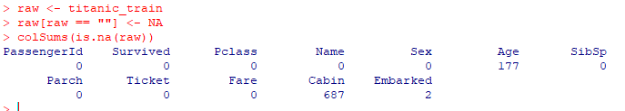
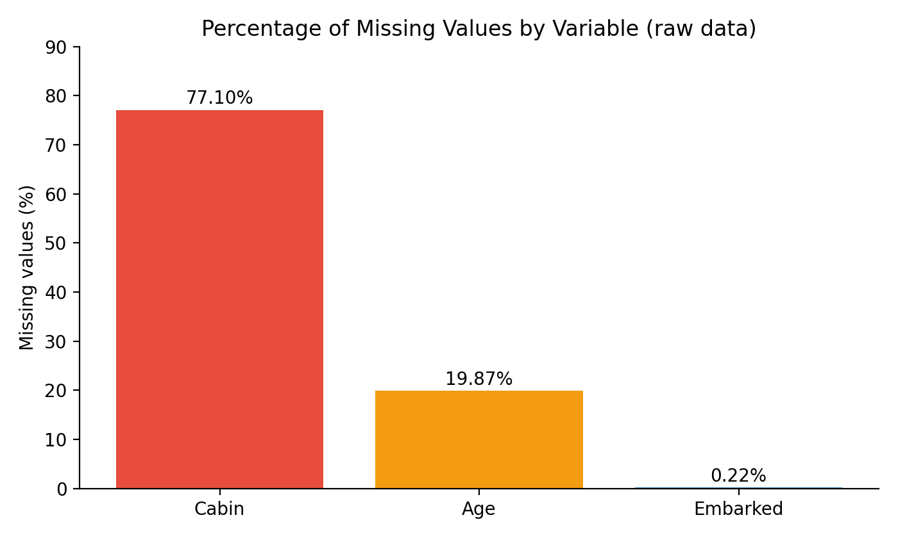
Figure 1: Percentage of missing values by variable (Week 1)

3.2 Outliers
Outliers were detected with the interquartile range (IQR) rule: values more than 1.5 IQRs beyond the quartiles are flagged. Age had 33 outliers and Fare had 116. The Age outliers are real elderly passengers (maximum 80 years) and were kept. Fare is extremely skewed (median 14.45, mean 32.20, maximum 512.33), so Fare was capped at the upper fence of 65.63 rather than deleted, which keeps every passenger while limiting the influence of extreme prices.
Annotated R code:
detect_outliers <- function(x) { # IQR rule
q <- quantile(x, c(0.25, 0.75), na.rm = TRUE)
iqr <- q[2] - q[1]
x < (q[1] - 1.5 * iqr) | x > (q[2] + 1.5 * iqr)
}
sum(detect_outliers(df$Age)); sum(detect_outliers(df$Fare))

q <- quantile(df$Fare, c(0.25, 0.75))
upper <- q[2] + 1.5 * (q[2] - q[1]) # = 65.63
df$Fare_capped <- pmin(df$Fare, upper) # cap (winsorize) extreme fares

Output:
Age outliers: 33
Fare outliers: 116

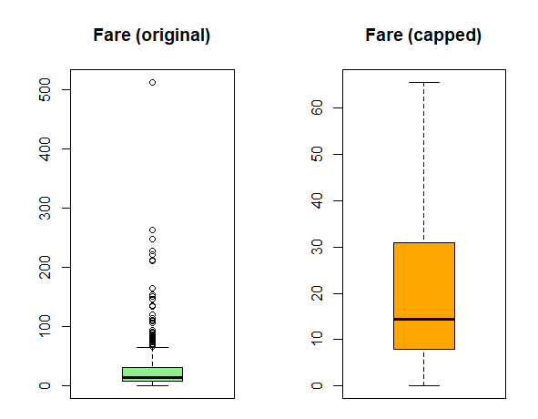
Figure 2: Fare before and after capping (Week 1)

3.3 Feature Engineering, Scaling and Encoding
- New variables: Title (extracted from Name and grouped into Mr, Mrs, Miss, Master, Rare) and FamilySize = SibSp + Parch + 1.
- Removed: PassengerId, Name and Ticket (identifiers with no usable pattern).
- Scaling: Age and capped Fare were rescaled to 0 to 1 (Min-Max); a Z-score version of Age was also created.
- Encoding: Survived and Sex as factors, Pclass as an ordered factor, Sex as a 0/1 label, and Embarked and Title as one-hot columns.
Annotated R code:
df$Title <- gsub("(.*, )|(\\..*)", "", df$Name) # extract title from name
df$FamilySize <- df$SibSp + df$Parch + 1

min_max <- function(x) (x - min(x)) / (max(x) - min(x))
df$Age_scaled <- min_max(df$Age) # 0 to 1
df$Fare_scaled <- min_max(df$Fare_capped)

df$Survived <- factor(df$Survived, levels = c(0, 1), labels = c("No", "Yes"))
df$Pclass <- factor(df$Pclass, levels = c(1, 2, 3), ordered = TRUE)
onehot <- model.matrix(~ Embarked + Title - 1, data = df) # one-hot encoding
df <- cbind(df, onehot)

saveRDS(df, "titanic_clean.rds") # reused in Weeks 2 to 4

The result is a clean dataset with 891 rows, no missing values and 23 columns. It is the foundation for every later step.
Link to the next step: With a trustworthy dataset in place, the next step was to look at it: first with summary statistics and correlations, then with visualizations designed for a non-technical audience.

4. Exploratory Analysis and Visualization (Weeks 1 and 2)

4.1 Summary Statistics and Correlations
Overall, 38.4% of passengers survived (61.6% did not). The mean age after imputation was 29.1 years (median 26), and Fare was strongly right-skewed. Survival rates differed sharply by group: 74.2% for women versus 18.9% for men, and 63.0%, 47.3% and 24.2% for first, second and third class.
Correlation with survival | r | Reading
Sex (male = 1) | -0.54 | Strongest link: men survived far less
Passenger class | -0.34 | Lower class, lower survival
Fare (capped) | 0.32 | Higher fare, higher survival (partly reflects class)
HasCabin | 0.32 | Recorded cabin, higher survival
Age | -0.06 | Weak linear link (the real pattern is non-linear, see 4.3)

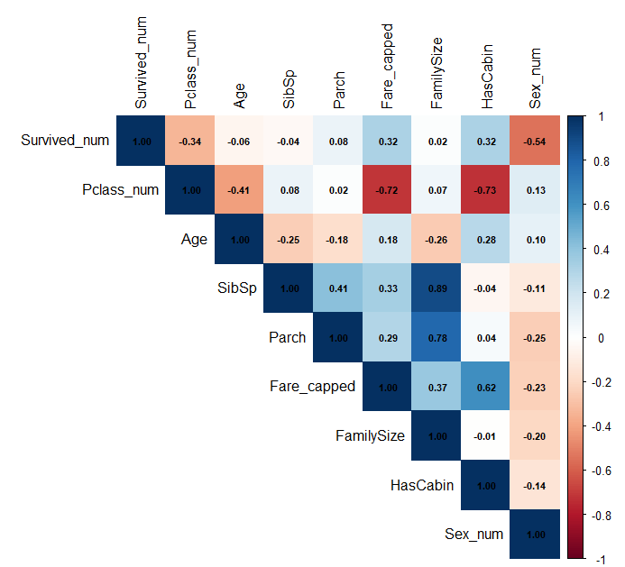
Figure 3: Correlation matrix of numeric variables (Week 1)
Interpretation: Sex and class are the strongest correlates of survival. Fare and class overlap heavily (r = -0.72), and SibSp and FamilySize are almost the same information (r = 0.89). Both facts matter later, when predictors are chosen for the model.

4.2 Who Survived? Class and Sex
Week 2 turned these numbers into charts. A bar chart of counts by class shows the size of each group, and a second chart shows survival rates for women and men within each class.
Annotated R code:
# Survival rate by sex within each class
rate_sc <- df %>% group_by(Pclass, Sex) %>%
summarise(rate = mean(Survived_num) * 100, n = n(), .groups = "drop")

ggplot(rate_sc, aes(x = Pclass, y = rate, fill = Sex)) +
geom_col(position = "dodge") + # grouped bars
geom_text(aes(label = paste0(round(rate, 1), "%")), # value labels
position = position_dodge(width = 0.9), vjust = -0.4) +
labs(title = "Survival Rate by Sex and Class",
x = "Passenger Class", y = "Survival Rate (%)") +
theme_minimal(base_size = 12)

Output:
Pclass Sex rate n
1 1 female 96.8 94
2 1 male 36.9 122
3 2 female 92.1 76
4 2 male 15.7 108
5 3 female 50 144
6 3 male 13.5 347

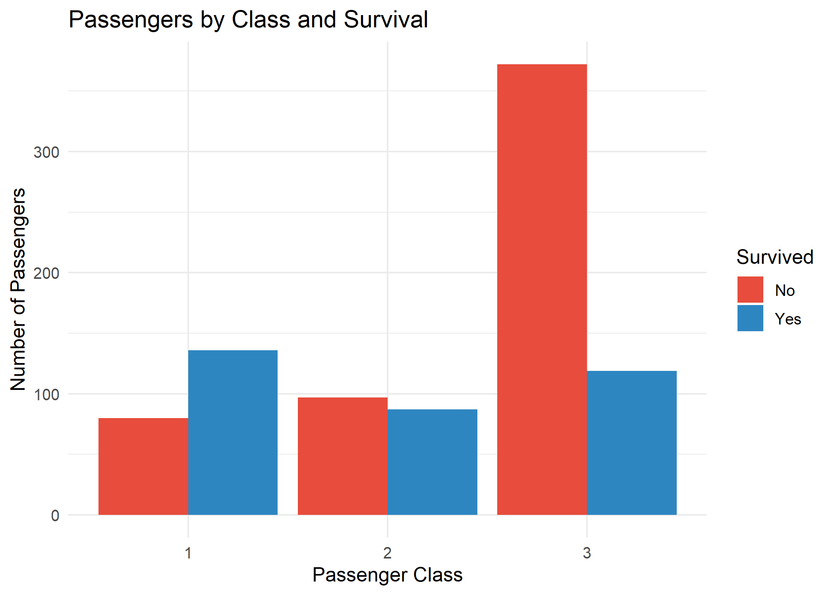
Figure 4: Passengers by class and survival (Week 2, Chart 1)
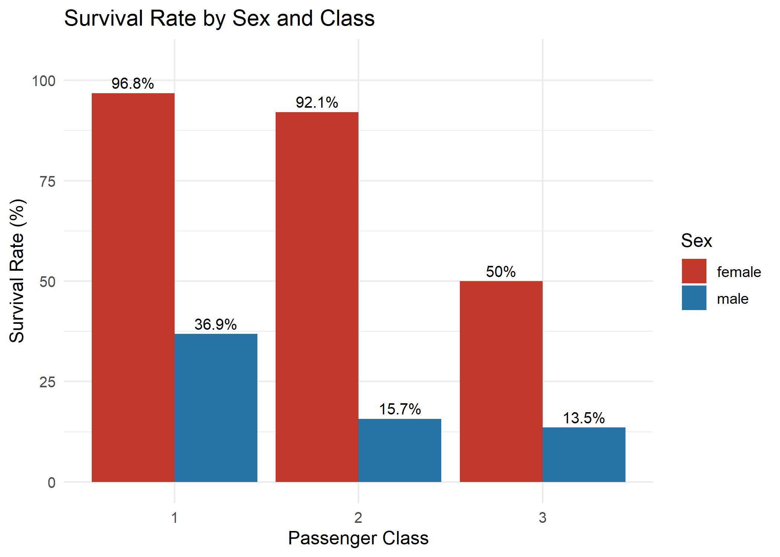
Figure 5: Survival rate by sex within each class (Week 2, Chart 2)
Interpretation: Third class was the largest group (491 passengers) and 372 of them did not survive, while 136 of 216 first-class passengers survived. Women did far better than men in every class (96.8% and 92.1% in first and second class), but only half of third-class women survived (50%). Class mattered most for women; for men, only first class offered a clearly better chance (36.9% versus 13.5% to 15.7%).

4.3 Age and Family Size
Annotated R code:
df$AgeGroup <- cut(df$Age, breaks = c(0, 12, 18, 30, 45, 60, Inf),
labels = c("0-12", "13-18", "19-30", "31-45", "46-60", "60+"))
age_rate <- df %>% group_by(AgeGroup) %>%
summarise(rate = mean(Survived_num) * 100, n = n(), .groups = "drop")

ggplot(age_rate, aes(x = AgeGroup, y = rate, group = 1)) +
geom_line(color = "#2E86C1", linewidth = 1.2) + # line shows the trend
geom_point(size = 3.5) + ylim(0, 80) +
labs(title = "Survival Rate by Age Group", y = "Survival Rate (%)") +
theme_minimal(base_size = 12)

Output:
AgeGroup rate n
1 0-12 58.0 69
2 13-18 42.9 70
3 19-30 32.1 417
4 31-45 43.1 232
5 46-60 40.7 81
6 60+ 22.7 22

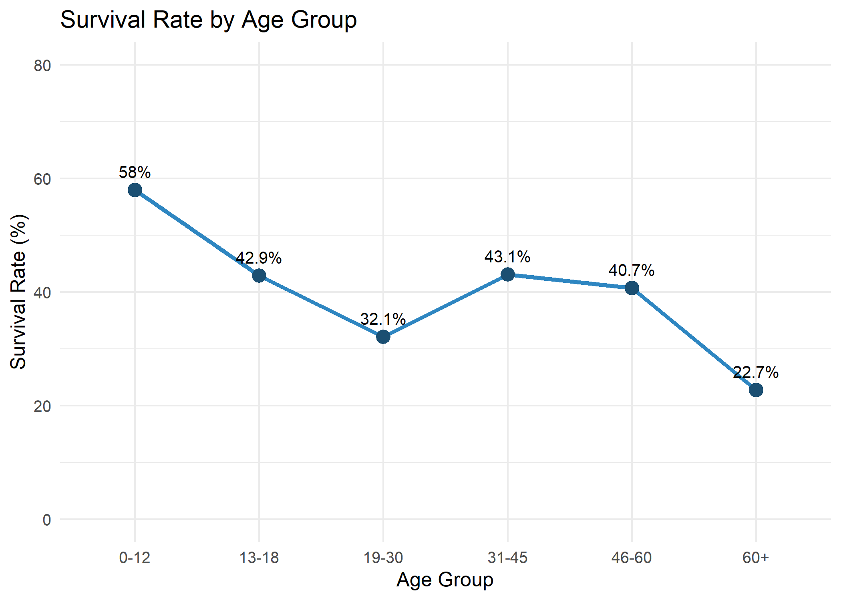
Figure 6: Survival rate by age group (Week 2, Chart 7)
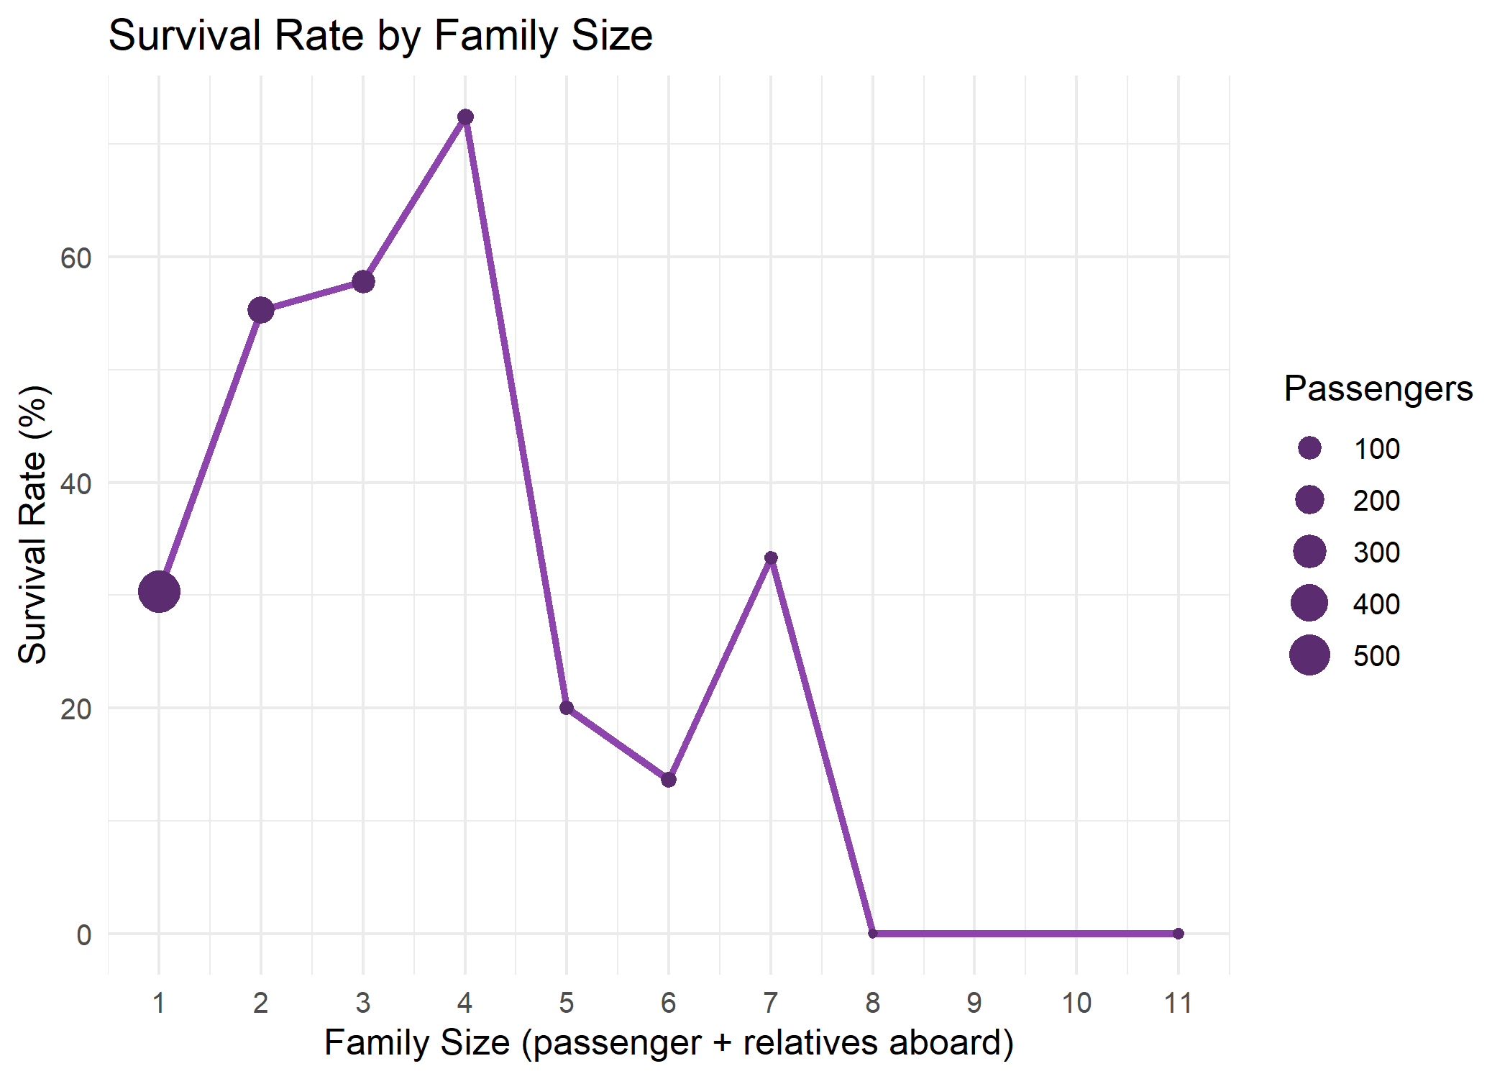
Figure 7: Survival rate by family size (Week 2, Chart 8)
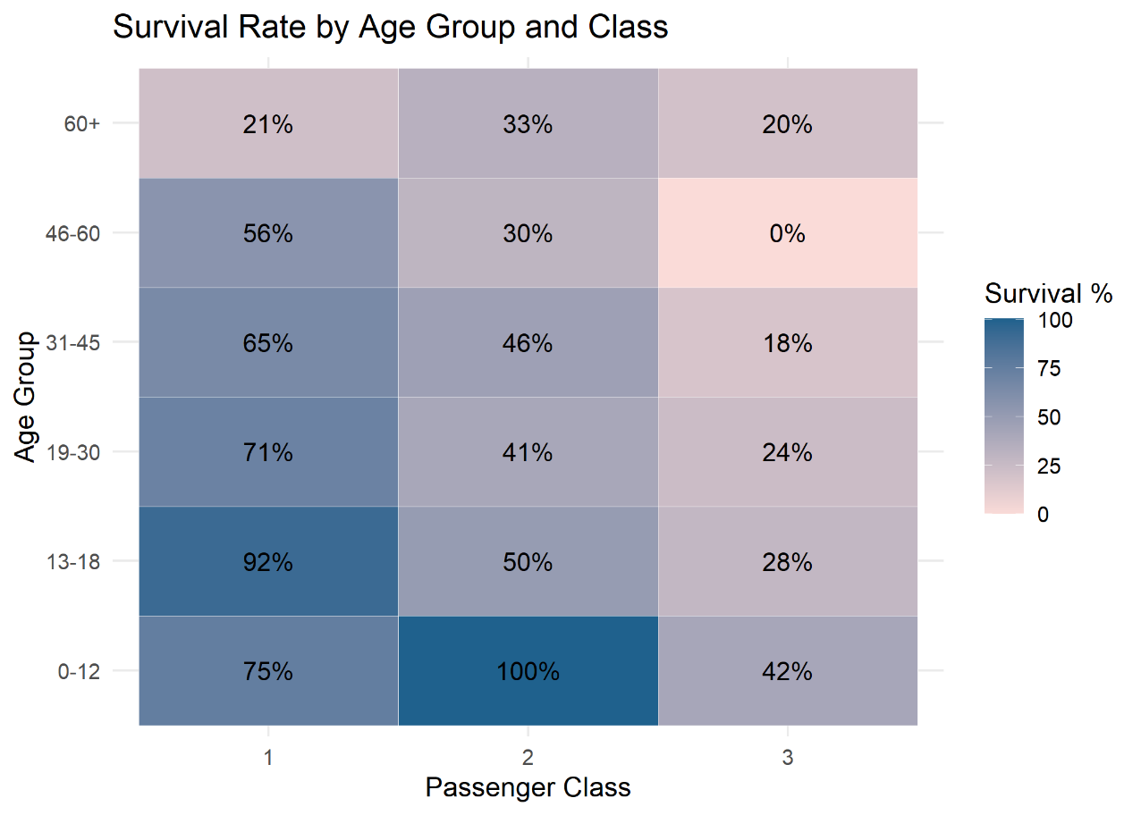
Figure 8: Survival rate by age group and class (Week 2, Chart 10)
Interpretation: Children aged 0 to 12 had the highest survival (58.0%), young adults aged 19 to 30 only 32.1%, and passengers over 60 the lowest (22.7%, but only 22 people). Family size shows a curve rather than a line: passengers travelling alone survived at 30.4%, families of two to four at 55.3%, 57.8% and 72.4%, and large families did poorly (20% for five and 13.6% for six). The heatmap shows that class and age act together: the best rates were for children and teenagers in first and second class, and the worst for older passengers in third class (for example 0% for ages 46 to 60 in third class). Some of these groups are small, so their exact percentages are less reliable.
Link to the next step: The charts suggest clear patterns, but patterns in a sample can be chance. Week 3 therefore tested each pattern formally.

5. Statistical Testing (Week 3)
Six hypotheses were set from the earlier findings and tested at a 5% significance level. First, the Shapiro-Wilk test showed that neither Age (W = 0.965, p = 1.1e-13) nor Fare (W = 0.787, p < 2.2e-16) is normally distributed, so non-parametric tests were used for them.
Annotated R code:
shapiro.test(df$Age) # normality check

chi_sex <- chisq.test(table(df$Sex, df$Survived)) # H1: sex vs survival
chi_class <- chisq.test(table(df$PclassF, df$Survived))# H2: class vs survival
t.test(Age ~ Survived, data = df) # H3: age (Welch t-test)
wilcox.test(Fare_capped ~ Survived, data = df) # H4: fare, non-parametric
summary(aov(Age ~ PclassF, data = df)) # H5: age across classes
cor.test(df$Fare_capped, as.numeric(df$PclassF),
method = "spearman", exact = FALSE) # H6: fare vs class

Output:
H1 Sex: X-squared = 260.72, df = 1, p < 2.2e-16 (Cramer's V = 0.541)
H2 Class: X-squared = 102.89, df = 2, p < 2.2e-16 (Cramer's V = 0.34)
H3 Age: t = 1.7432, p = 0.08175 (Wilcoxon p = 0.25)
H5 ANOVA: F = 93.24, p < 2e-16 (Tukey: all class pairs differ)

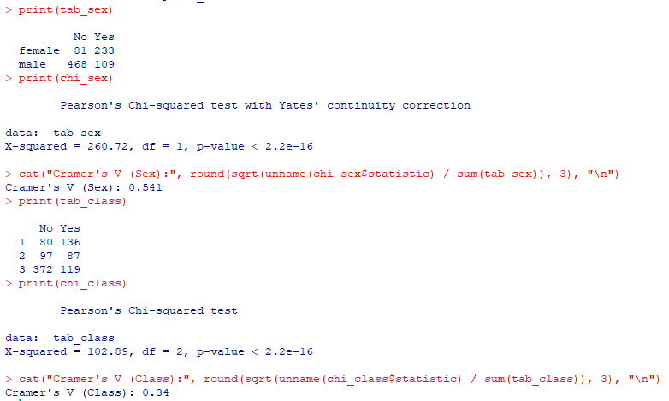
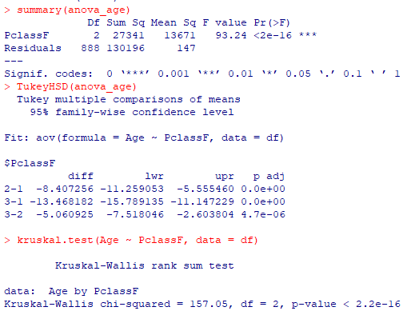
ID | Hypothesis | Test and statistic | p-value | Decision
H1 | Survival depends on sex | Chi-square 260.72; V = 0.54 | < 2.2e-16 | Reject H0
H2 | Survival depends on class | Chi-square 102.89; V = 0.34 | < 2.2e-16 | Reject H0
H3 | Age differs by survival | t = 1.74; Wilcoxon W = 98172 | 0.082; 0.25 | Fail to reject
H4 | Fare differs by survival | Wilcoxon W = 58208 | < 2.2e-16 | Reject H0
H5 | Age differs across classes | ANOVA F = 93.24; Kruskal 157.05 | < 2e-16 | Reject H0
H6 | Fare correlated with class | Spearman rho = -0.684 | < 2.2e-16 | Reject H0

Interpretation: Sex and class are strongly and significantly related to survival, and sex is the stronger of the two. Survivors paid much higher fares (median 26.0 versus 10.5). Passengers in higher classes were older: Tukey tests show second class is 8.4 years younger than first class and third class is 13.5 years younger. The one non-significant result is H3: the average ages of survivors (28.1) and non-survivors (29.7) do not differ significantly. This agrees with Week 2, where age mattered only for the youngest and the oldest groups, so the two group averages end up close.
Link to the next step: Having confirmed which factors are statistically important, the next step was to combine them in one model that can predict survival for an individual passenger.

6. Predictive Modeling (Week 3)

6.1 Model Design
Logistic regression was chosen because the outcome is binary and because its odds ratios are easy to explain. Predictors were Passenger Class, Sex, Age, FamilySize, Fare (capped), Port of Embarkation and HasCabin. SibSp and Parch were excluded because FamilySize is built from them, and Title was excluded because it largely repeats Sex. The data was split 80% for training (713 passengers) and 20% for testing (178 passengers), and the training data was further evaluated with 10-fold cross-validation.
Annotated R code:
set.seed(123) # reproducible split
train_idx <- sample(seq_len(nrow(df)), size = round(0.8 * nrow(df)))
train <- df[train_idx, ]; test <- df[-train_idx, ]

# Model 1: baseline
f1 <- Survived_num ~ PclassF + Sex + Age + FamilySize + Fare_capped + Embarked + HasCabin
m1 <- glm(f1, data = train, family = binomial)
exp(cbind(OR = coef(m1), confint.default(m1))) # odds ratios

# Model 2: adds class-by-sex interaction and a curved family-size term
f2 <- Survived_num ~ PclassF * Sex + Age + FamilySize + I(FamilySize^2) +
Fare_capped + Embarked + HasCabin
m2 <- glm(f2, data = train, family = binomial)

cv1 <- cv_glm(f1, train); cv2 <- cv_glm(f2, train) # 10-fold cross-validation
anova(m1, m2, test = "Chisq") # does Model 2 fit better?

6.2 What the Model Says
Predictor (Model 1) | Odds ratio | 95% CI | p-value | Meaning
Male (vs female) | 0.065 | 0.041 to 0.101 | < 0.001 | Odds about 93.5% lower
Class 3 (vs class 1) | 0.322 | 0.112 to 0.925 | 0.035 | Odds about 68% lower
Age (per year) | 0.961 | 0.944 to 0.979 | < 0.001 | Each year lowers odds by about 3.9%
FamilySize (per person) | 0.752 | 0.629 to 0.899 | 0.002 | Each relative lowers odds by about 24.8%
HasCabin | 2.852 | 1.322 to 6.152 | 0.008 | Odds 2.85 times higher
Embarked S (vs C) | 0.544 | 0.322 to 0.919 | 0.023 | Odds about 45.6% lower
Class 2, Fare, Embarked Q | 0.98 to 1.01 | wide | > 0.27 | Not significant

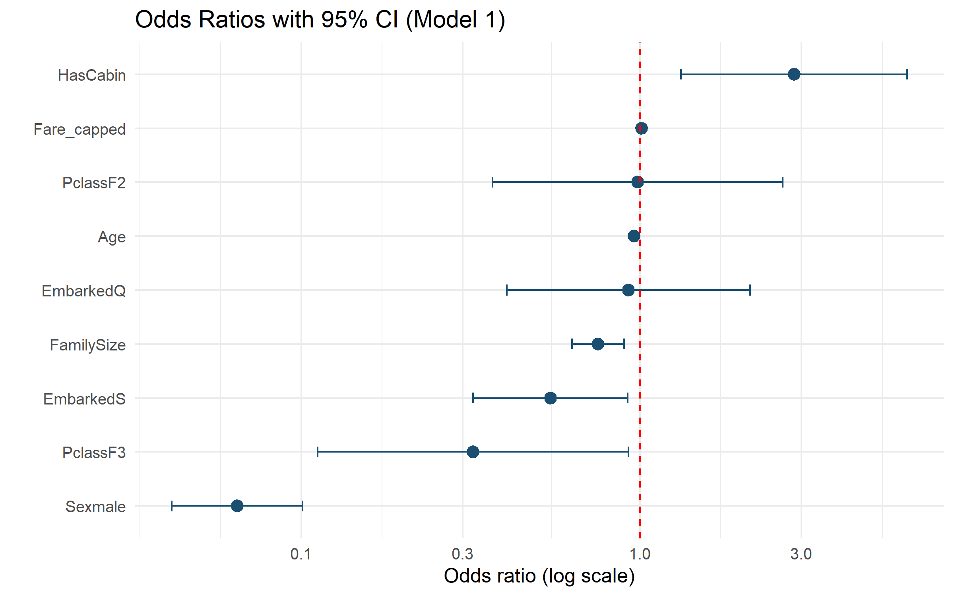
Figure 9: Odds ratios with 95% confidence intervals, Model 1 (Week 3)
Interpretation: Sex is by far the strongest predictor, followed by age, family size, third class and having a cabin. Fare and class 2 are not significant once the others are included, because class, fare and cabin carry overlapping information (all adjusted VIF values were below 2, so the overlap is mild and does not invalidate the model).

6.3 How Well Does It Predict?
Output:
Model 1 CV mean accuracy: 0.816 mean AUC: 0.849
Model 2 CV mean accuracy: 0.821 mean AUC: 0.861

Model CV_Accuracy CV_AUC Test_Accuracy Test_Precision Test_Recall Test_F1 Test_AUC
1 Model 1 (baseline) 0.816 0.849 0.781 0.734 0.681 0.707 0.859
2 Model 2 (improved) 0.821 0.861 0.803 0.804 0.652 0.720 0.853

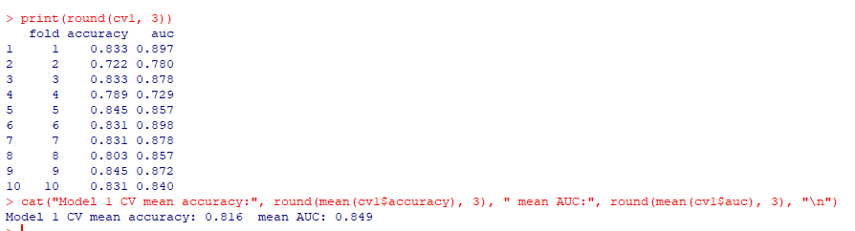
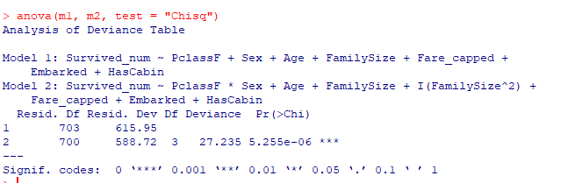
Model | CV acc. | CV AUC | Test acc. | Test prec. | Test recall | Test F1 | Test AUC
Model 1 (baseline) | 0.816 | 0.849 | 0.781 | 0.734 | 0.681 | 0.707 | 0.859
Model 2 (improved) | 0.821 | 0.861 | 0.803 | 0.804 | 0.652 | 0.720 | 0.853

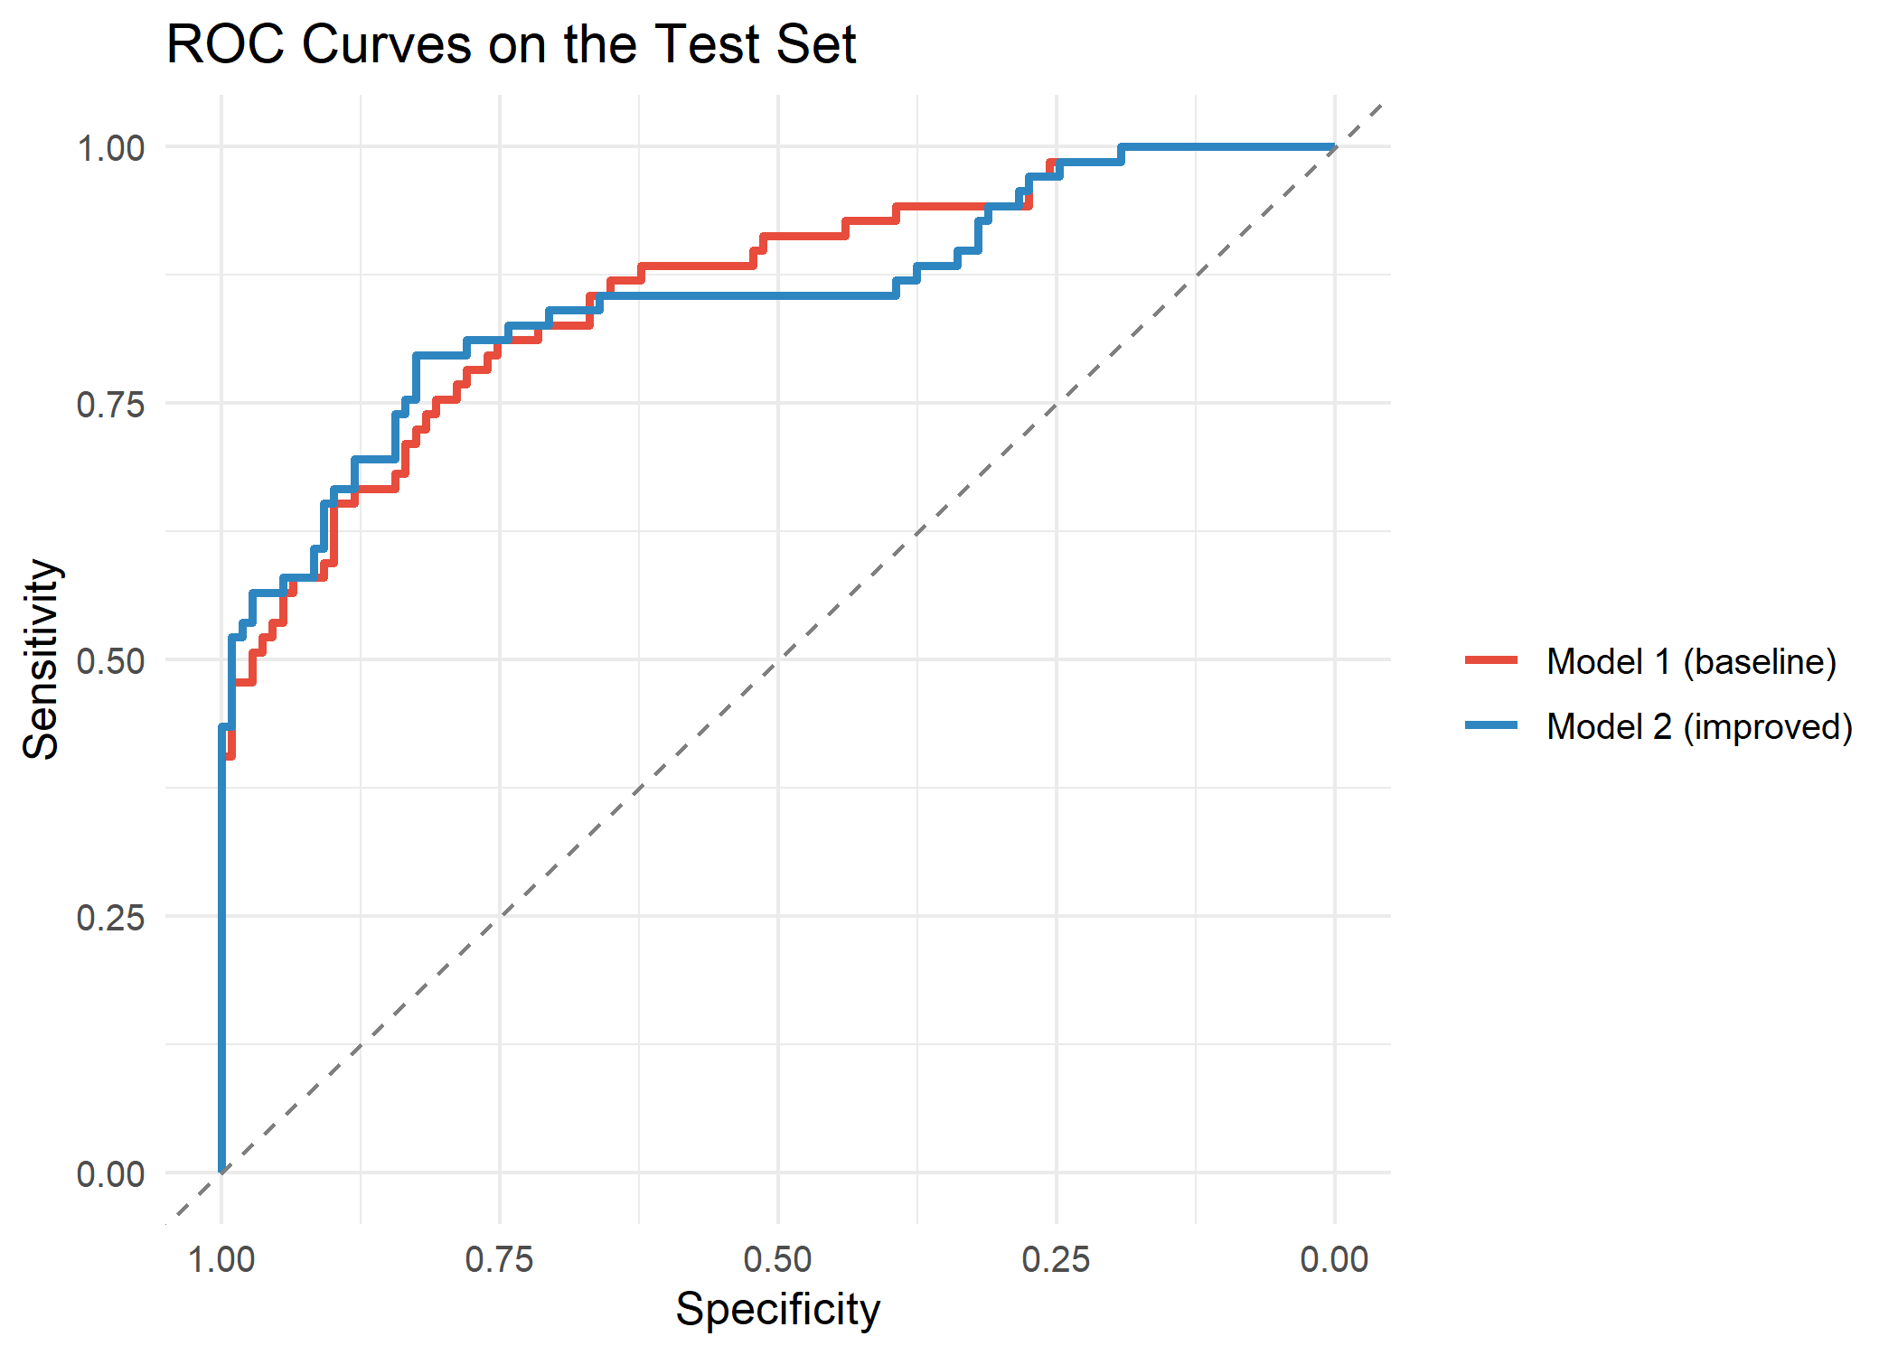
Figure 10: ROC curves of both models on the test set (Week 3)
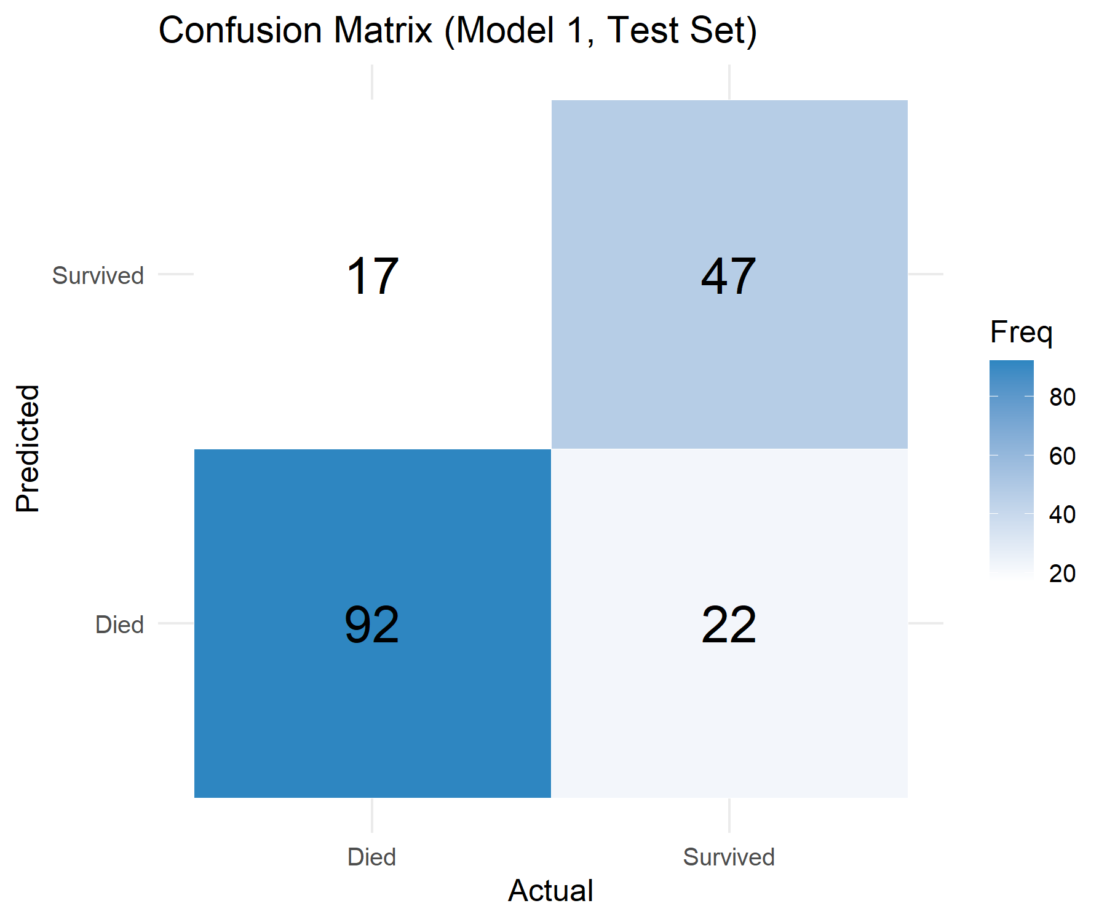
Figure 11: Confusion matrix of Model 1 on the test set (Week 3)
Interpretation: Both models classify about four in five passengers correctly and rank survivors above non-survivors well (AUC about 0.85 to 0.86). Model 2 fits the training data significantly better (likelihood ratio test p = 5.3e-06; AIC 614.7 versus 636.0) and has better cross-validated results, mainly because the class-by-sex interaction is significant (p = 0.0098): the gap between men and women is smaller in third class, where women survived at only 50%. The gain on the small test set is modest and its test AUC is marginally lower, so the improvement should be described as real but small. The model's main weakness is recall: at the default 0.5 threshold it finds only 65% to 68% of actual survivors. Lowering the threshold to 0.3 raises recall to 0.797 and gives the best F1 score (0.748) at the cost of more false alarms.
Link to the next step: The statistics and the model each answer part of the question. The next section puts them side by side to see how well they agree.

7. Integrated Results and Discussion

7.1 One Story, Four Kinds of Evidence
The strength of this project is that every main finding was reached in more than one way. The table below shows how each factor appeared in the correlations (Week 1), the charts (Week 2), the hypothesis tests (Week 3) and the model (Week 3).
Factor | Correlation (W1) | Charts (W2) | Test (W3) | Model (W3)
Sex | r = -0.54 | 74.2% women vs 18.9% men | V = 0.54, p < 2.2e-16 | OR 0.065 for men
Class | r = -0.34 | 63.0%, 47.3%, 24.2% | V = 0.34, p < 2.2e-16 | OR 0.322 for class 3
Age | r = -0.06 | Children 58.0%; over 60 22.7% | Mean age p = 0.082 (n.s.) | OR 0.961 per year (significant)
Family size | High overlap with SibSp (0.89) | Peak at 4 (72.4%); large families low | Not tested directly | OR 0.752 per person
Fare | r = 0.32 | Skewed; capped at 65.63 | p < 2.2e-16 | OR 1.010 (n.s.)
Cabin recorded | r = 0.32 | n/a | n/a | OR 2.852

Two results deserve special attention. First, age looks unimportant in a simple correlation (r = -0.06) and in the t-test, yet it is significant in the model and clearly matters for the youngest and oldest groups in the charts. A single summary number can hide a non-linear pattern, which is why visualization and modelling are needed alongside basic statistics. Second, fare looks important in the correlation and the Wilcoxon test but disappears in the model, because it mostly reflects passenger class. This shows why a model that controls for several variables at once gives a more honest picture than one-variable comparisons.

7.2 Business and Practical Implications
The Titanic is a historical case, so these points are lessons about method and about how outcomes can be shaped by rules and circumstances, not claims about causes.
- Segmentation: the analysis identifies which groups faced the highest risk (men, third-class passengers, older passengers and large families). In a business or safety setting the same approach tells decision-makers where to focus resources and attention.
- Policy effects are measurable: the very high survival of women and children, and the clear gradient by class, show how rules and access shape outcomes. Data lets an organisation check whether a policy was applied fairly across groups.
- Prediction needs a decision about errors: the threshold analysis shows that the "best" model depends on cost. If missing a survivor is costly, a lower threshold is better; if false alarms are costly, a higher one is better. The same trade-off applies to fraud, churn or medical screening models.
- Data quality has a direct cost: 77% of Cabin values were missing and 20% of Age values had to be estimated. Collecting complete data at the source would improve every later analysis.
- Communicate to the audience: charts with consistent colours, plain-language interpretations and odds ratios made technical results understandable to non-specialists.

8. Challenges Encountered and How They Were Overcome
Challenge | How it was addressed
77% of Cabin values missing | Replaced the column by a HasCabin flag instead of guessing values; the flag turned out to be a significant predictor.
20% of Age values missing | Imputed with the median within each class and sex group; noted as a limitation because it creates a spike near age 24 in the histogram.
Extremely skewed Fare with 116 outliers | Capped at the IQR upper fence (65.63) to keep all passengers while limiting the effect of extreme prices.
Variables that are not normally distributed | Checked with Shapiro-Wilk tests and Q-Q plots, then used non-parametric tests (Wilcoxon, Kruskal-Wallis, Spearman) beside parametric ones.
Overlapping predictors (class, fare, cabin; SibSp and FamilySize) | Dropped SibSp and Parch, excluded Title, and checked variance inflation factors (all adjusted values below 2); interpreted fare and class 2 results with care.
Small groups in charts (60+, large families) | Showed group sizes beside percentages and flagged unreliable estimates in the text.
One test split can be misleading | Used 10-fold cross-validation as well as a hold-out test set, and compared both.
A formula error in the analysis | Cramer's V for the 3 by 2 class table was first computed with the wrong divisor (0.24). Checking the formula showed the correct value is 0.34, and the script and reports were corrected.
Technical setup | Installing packages (pROC, car), setting the working directory and organizing outputs into plots, plots_week2 and plots_week3 folders so the work is reproducible.

9. Lessons Learned
- Clean data first: every later result depends on the cleaning choices, so each choice should be explained and justified.
- Look before testing, and test before modelling: charts suggested the questions, tests confirmed which patterns are real, and the model combined them.
- Check results in more than one way: findings supported by correlations, charts, tests and a model are far more trustworthy than any single result.
- A single number can mislead: age looked unimportant in a correlation but mattered in the model, and fare looked important until class was controlled for.
- Report honest results: the improved model gained only a modest amount on the test set, and saying so is better than overstating it.
- Verify the work: checking formulas and outputs (as with Cramer's V) is part of good analysis, not a sign of failure.
- Explain in plain language: results are only useful if the audience can understand and act on them.

10. Limitations, Recommendations and Future Directions

10.1 Limitations
- The analysis shows associations, not causes; sex, class and age are linked to each other, so their effects overlap.
- About 20% of ages were estimated, which adds uncertainty to age-related findings.
- The test set is small (178 passengers), so differences of one or two percentage points between models are within normal variation.
- Only logistic regression was fitted, with no regularization or tuning, and recall at the default threshold is only 65% to 68%.
- The dataset covers only the 891 passengers of the Kaggle training file, not all people aboard.

10.2 Recommendations for Further Analysis
- Compare logistic regression with random forests or gradient boosting using the same cross-validation folds.
- Add information not yet used: Title in place of Sex, surnames and ticket numbers to build family groups, and deck letters from Cabin.
- Improve age imputation with a model based on Title, class and family size instead of group medians.
- Use repeated cross-validation and regularized regression (lasso or ridge) for more stable estimates.
- Choose the decision threshold according to the goal; for example about 0.3 if finding survivors matters most.

10.3 Future Directions
- Build an interactive dashboard (for example with Shiny) so non-technical users can explore survival by group.
- Package the cleaning, testing and modelling steps into reusable functions or an R Markdown report that regenerates automatically when new data arrives.
- Apply the same workflow to a business dataset, such as customer churn or loan default, to practise turning model results into decisions.

11. Conclusion
This project followed one dataset through the full data-analysis cycle. The data was cleaned carefully, with every missing value, outlier and encoding choice explained. Visualizations showed that survival depended strongly on sex, passenger class, age and family size. Hypothesis tests confirmed that sex (Cramer's V = 0.54) and class (V = 0.34) are significantly related to survival, and a logistic regression model combined the factors into a predictor with about 82% cross-validated accuracy and an AUC of about 0.85 to 0.86.
The most important lesson is the value of a data-driven approach. Instead of relying on opinion or a single statistic, each conclusion here is supported by several kinds of evidence, tested for statistical significance, checked with diagnostics, and reported together with its limits. That discipline is what makes data analysis trustworthy and useful for decisions. The recommended next steps, which include more flexible models, better features and an interactive dashboard, build directly on the foundation created in these four weeks.

Appendix: Project Files
All code and outputs are stored in the project repository: https://github.com/Abinisha-P/r-titanic-data-analysis
Script | Main output | Plots folder
week1_titanic_cleaning.R | titanic_clean.rds and titanic_clean.csv | Plots_week1(8 charts)
week2_titanic_visualization.R | 10 high-resolution charts | plots_week2 (10 charts)
week3_titanic_modeling.R | Hypothesis tests, Model 1 and Model 2, titanic_model_week3.rds | plots_week3 (7 charts)

R packages used: dplyr (data manipulation), ggplot2 (visualization), corrplot (correlation plot), pROC (ROC curves and AUC) and car (variance inflation factors).

